Name: Nooreldeen Ayman Mohammed Elmobashar
Track: Open Source
Branch: ITI Mansoura
_____________________________________________________________

1. Install Linux

Done. Fedora Installed.

2. What is the difference between cat and more?

cat views all the file content in one time.
more views file content page by page.

3. What is the difference between rm and rmdir using man?

rm is used to delete files and directories (using flags).
rmdir only removes empty folders only.

4. Create the following hierarchy under your home directory

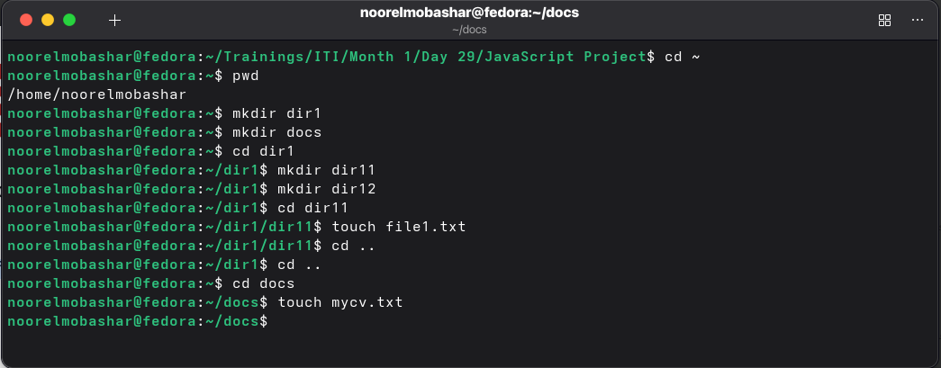

4.a Remove dir11 in one-step. What did you notice? And how did you overcome that?

I know that I should use rm -rf dir11 command to delete all the files and directories inside dir11

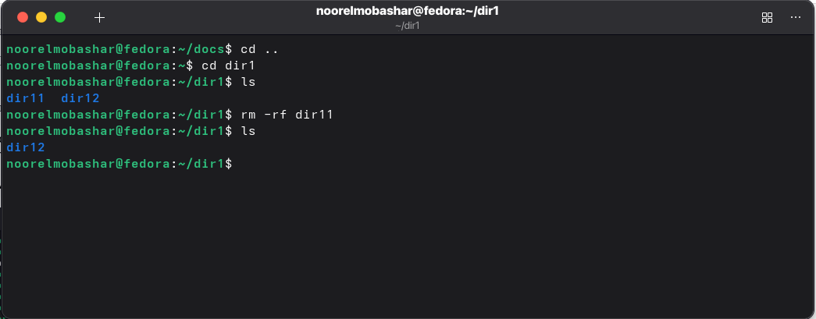

4.b Then remove dir12 using rmdir –p command. State what happened to the
hierarchy (Note: you are in your home directory).

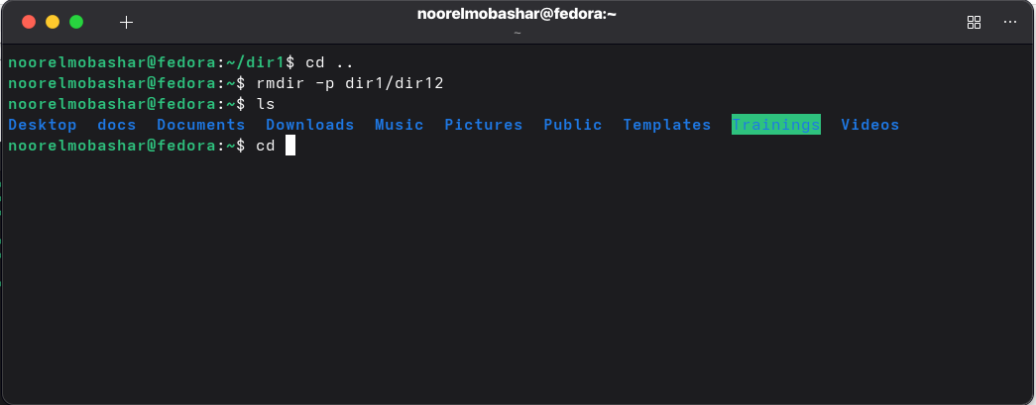
I notice that dir12 is removed and its parent is removed also.

4.c The output of the command pwd was /home/user. Write the absolute
and relative path for the file mycv

Absolute Path: /home/noorelmobashar/docs/mycv.txt
Relative Path: docs/mycv.txt

5. Copy the /etc/passwd file to your home directory making its name is mypasswd.

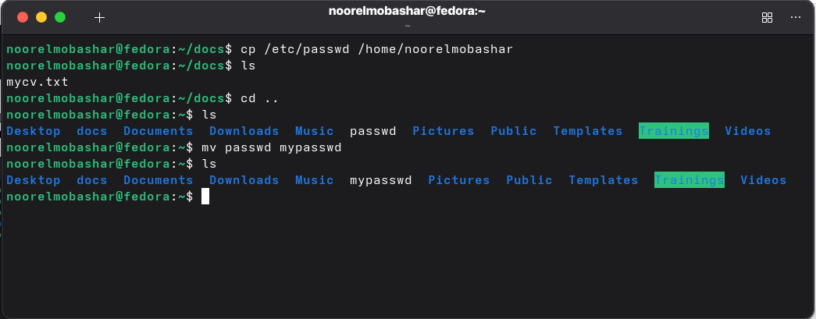

6. Rename this new file to be oldpasswd.

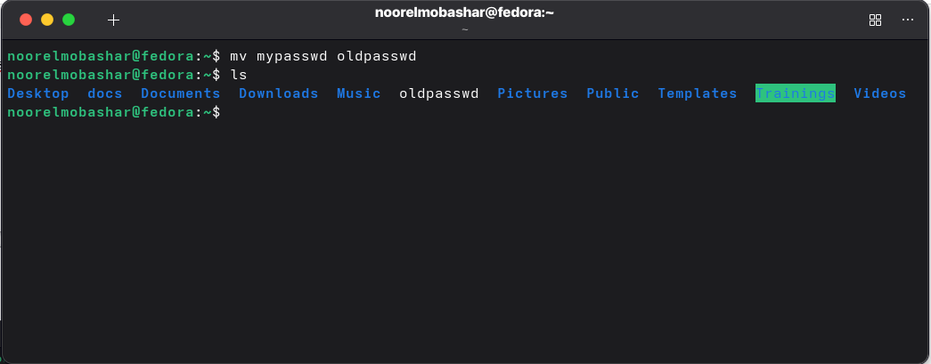

7. You are in /usr/bin, list four ways to go to your home directory

1. cd /home/noorelmobashar
2. cd ~
3. cd
4. cd $HOME

8. List Linux commands in /usr/bin that start with letter w

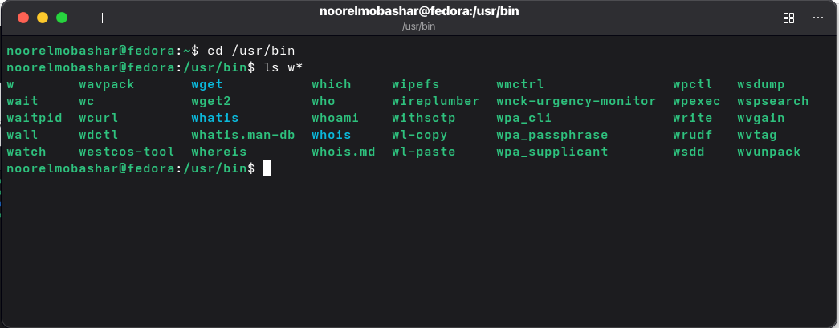

9. Display the first 4 lines of /etc/passwd

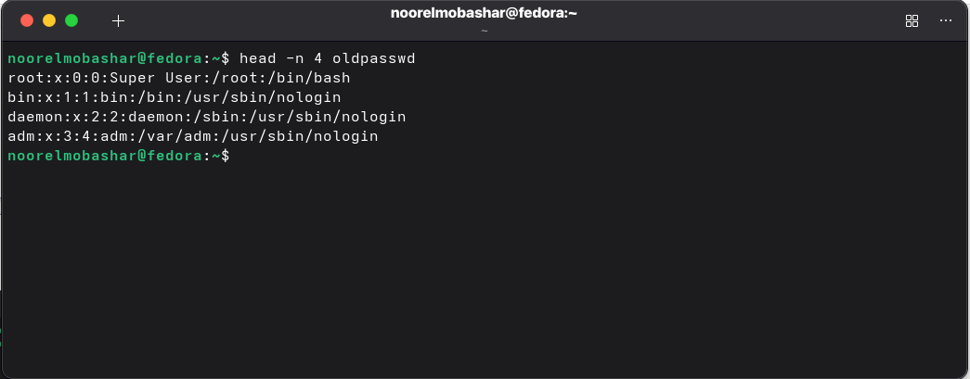

10.Display the last 7 lines of /etc/passwd

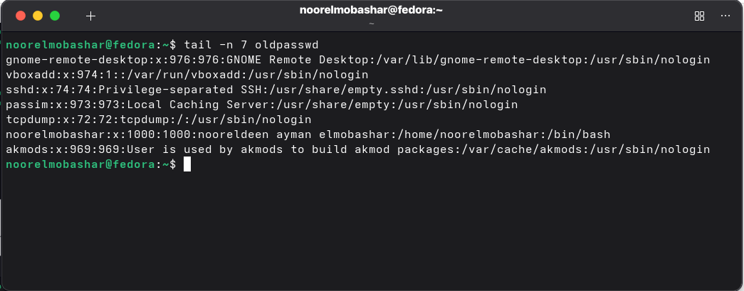

11.Display the man pages of passwd the command and the file sequentially in one command.

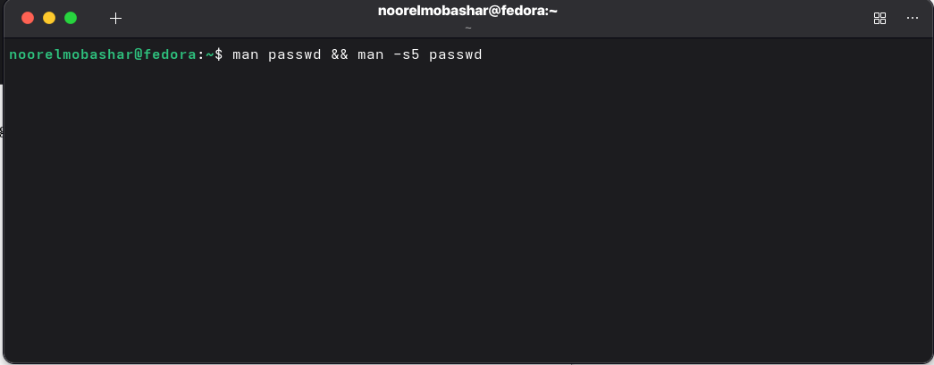
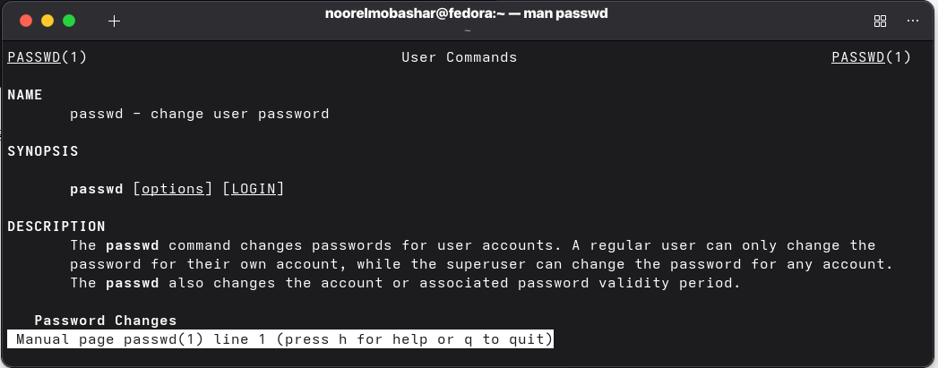
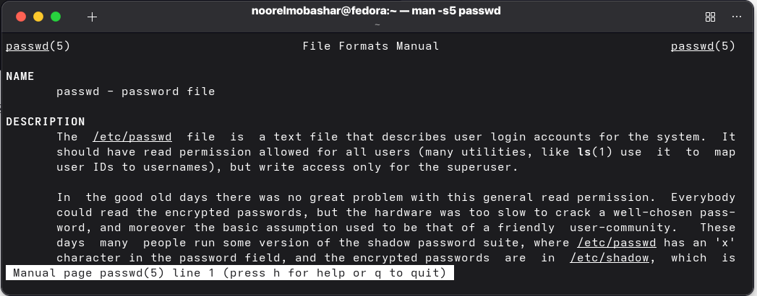

12.Display the man page of the passwd file.

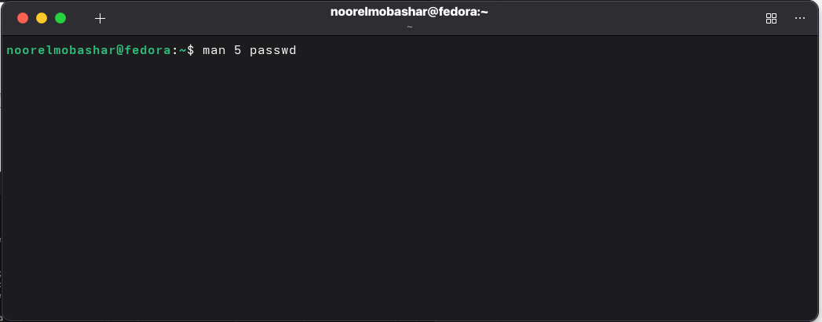
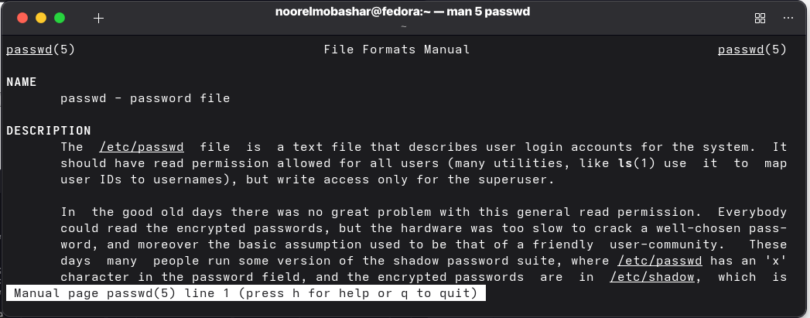
13.Display a list of all the commands that contain the keyword passwd in their man page.

